DIP Homework #1
Due Date: Apr. 10 (Tuesday), 18:00

There are three problems for this assignment:

Problem 1 (required for every student): Error Diffusion
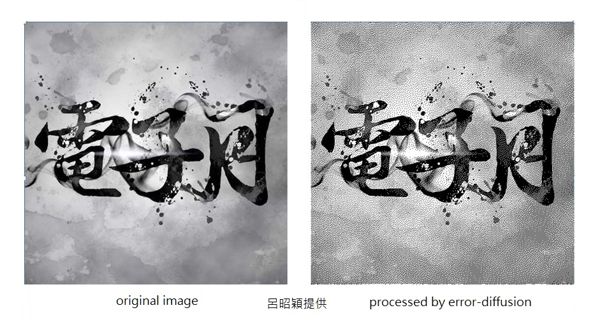
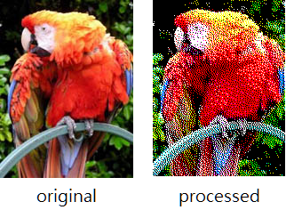
Problem 2: You have the options to choose one (just one is needed) from the following problems:
(1) lowpass filtering
(2) directional smoothing
(3) median filtering
(4) adaptive smoothing
(5) adaptive median filtering
(6) highpass filtering
(7) fun with colors (e.g., color modification, pseudo-coloring, etc.)
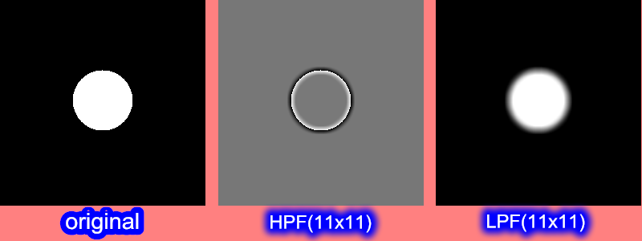

Problem 3: You have the options to choose one (just one is needed) from the following problems:
(1) histogram equalization
Use boat.bmp as a test image. Of course you can also use other images that can exhibit the effect of histogram equalization clearly.
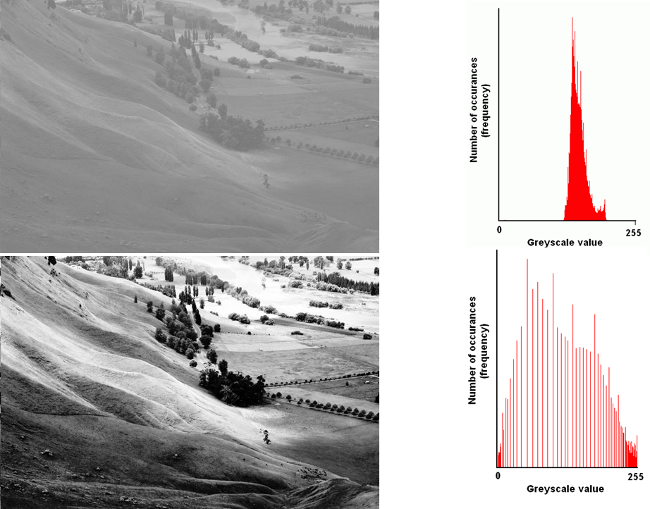

(2) edge sharpening

Notes:
- For the median filtering problem, use the attached image (lena_noisy_pepper&salt.bmp) as the input test file.
- For all other problems, you can use your own images. Either gray-scale or full-colored images are acceptable. I would suggest that you try some colorful pictures which may look more interesting.
- Pay attention to the out-of-range problem in displaying the HPF result. You can employ any of the techniques discussed in class. In the figure shown on the previous page, the highpass-filtered image is displayed after applying linear scaling of the gray levels.
- Note that in the package I forward to each of you, it includes main.cpp, bmp.cpp, bmp.h, two test images (lena_noisy_pepper&salt, boat.bmp), a sample report ((報告範例)u9713151李柏勳_HW5), DIP作業上傳須知.doc, and this readme file.

